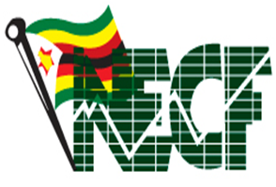

**NATIONAL ECONOMIC CONSULTATIVE FORUM**

**QUARTERLY ENVIRONMENTAL ANALYSIS (PESTEL)**

**30 JUNE 2024**

# Executive Summary

This quarterly environmental analysis report focused on the political, economic, social, technological, legal and environmental (PESTEL) developments for the quarter ending 30 June 2024.

Politically the global geopolitical tensions and conflicts were rising, notably in the Middle East and Ukraine, impacting global stability and economic outlooks. In Sub-Saharan Africa, political instability continued to challenge regional growth. However, Zimbabwe maintained political stability and was preparing to host the 44th Ordinary SADC Summit, which will boost its international profile and foster regional cooperation.

The global economy showed signs of stabilization, with a projected growth rate of 2.6% for 2024, slightly increasing to 2.7% in 2025. Inflation remains a concern, averaging 3.5% globally. Advanced economies are experiencing slower growth, while emerging markets, including Sub-Saharan Africa, are seeing robust growth rates. In Zimbabwe, economic growth is expected to reach 3.5% in 2024 down from 5.5% registered in 2023 due to drought impacts, with inflation showing a downward trend. The introduction of the Zimbabwe Gold (ZiG) currency aimed to stabilize the economy, supported by a strong external sector and public debt management efforts are some of the highlights on macroeconomic developments during the second quarter of 2024.

Socially Zimbabwe faces significant social challenges, including education and health issues exacerbated by an El Niño-induced drought. The drought threatens food security, with 7.7 million people needing food assistance. Education initiatives continue multiply, but the drought risk is increasing school dropouts particularly in the rural communities. Health concerns include a cholera outbreak and rising drug abuse, prompting government action plans and international cooperation.

Technologically the African Development Bank and Intel launched an initiative to enhance Artificial Intelligence (AI) skills across Africa. Zimbabwe's Digitalize Zimbabwe Campaign is promoting digital infrastructure development, supported by government investments in telecommunications to prepare for the upcoming SADC Summit. These efforts aim to enhance digital inclusion and e-government services in the country.

Legal reforms in Zimbabwe focused on anti-corruption measures and transparency, crucial for engagement and re-engagement with the international community as well as arrears clearance and debt resolution. .

Environmentally, global and national efforts are underway to address land degradation and climate change. The theme for World Environment Day 2024, "Land Restoration, Desertification, and Drought Resilience," underscored the urgency of these issues. Zimbabwe is actively involved in these efforts, preparing for future environmental challenges.

Overall, the PESTEL analysis highlights a cautiously optimistic global economic outlook, with specific challenges and opportunities for Zimbabwe in political stability, economic reform, social welfare, technological advancement, legal transparency, and environmental sustainability

**Contents**

Executive Summary i

List of Figures iv

List of Tables v

1.0 Global Market Environment 1

1.1 World GDP 1

1.2 Regional Economic Developments 1

3.0 Economic Factors 3

3.1 GDP Performance 3

3.2 Inflation 4

3.3 Balance of Payments Developments 5

3.4 Public Debt Developments 6

3.5 New Currency Introduction 8

3.6 Exchange Rate System 8

3.7 Money Supply and Interest Rate Developments 9

3.8 Equity Market Developments 10

3.9 Exchange Rate Developments 11

4.0 Social Factors 11

4.1 Education 11

4.2 Health 12

4.3 Poverty and Hunger 12

5.0 Technological Factors 13

6.0 Environmental Factors 14

7.0 Legal Factors 15

8.0 Recommendations 15

9.0 References 17

Annexes 18

Annexture A: PESTEL-SWOT Analysis Matrix for the Quarter Ending 30 JUNE 2024 18

# List of Figures

**Figure 1: World Economic Developments 2023-2025 1**

**Figure 2: Zimbabwe Economic Growth Prospects 4**

**Figure 3: Inflation Developments 5**

**Figure 4: Current Account Developments 6**

**Figure 5: Exchange Rate Movements 9**

# List of Tables

**Table 1:Selected SADC Countries GDP Growth Projections (%) 2**

**Table 2: Total Debt Stock as at 30 June 2024 (ZiG millions) 7**

**Table 3: Zimbabwe Stock Exchange Movements 10**

**Table 4: Victoria Falls Stock Exchange Movements 11**

**Table 5: ZiG Exchange Rate Movements 11**

**Table 6: Grain Distributed by Provinces 13**

# 1.0 Global Market Environment

## 1.1 World GDP

1.1.1 The global economy is currently exhibiting signs of stabilization after experiencing multiple years of adverse shocks. According to World Bank, the forecast for global growth in 2024 is anticipated to remain steady at 2.6%, an upward revision of 0.2 percentage points from the projections made in January. This resilience is observed despite the persistent challenges posed by heightened geopolitical tensions and elevated interest rates. Looking ahead to 2025, global growth is expected to see a marginal increase to 2.7%, consistent with earlier forecasts. These projections underscore a cautiously optimistic outlook for the global economy, as it navigates through the complexities of the current economic landscape.

1.1.2 Global inflation is anticipated to decelerate more slowly than previously expected, averaging 3.5% this year. Central banks in both advanced and emerging market economies are likely to adopt a cautious approach to easing policy. Consequently, interest rates are expected to remain significantly higher than pre-pandemic levels for an extended period. Despite some improvements, the overall outlook remains subdued.

Figure 1: World Economic Developments in GDP 2023-2025

*Source: Global Economic Prospects-World Bank (June 2024)*

## 1.2 Regional Economic Developments

1.2.1 According to World Bank Global Economic Prospects Report, in 2024, advanced economies are projected to witness constant growth at 1.5% in both 2023 and 2024. This constant rate is primarily driven by the impact of restrictive fiscal and monetary policies, which are tempering economic expansion. In contrast, emerging markets and developing economies are expected to maintain a robust growth rate of 4% for the year.

1.2.2 Additionally, Sub-Saharan Africa (SSA) is anticipated to experience a positive growth trend, with forecasts indicating an increase to 3.5% in 2024, compared to an estimated 3.0% in 2023. The region’s economic growth this year is driven by a resurgence in domestic demand after a sluggish performance in 2023. Nevertheless, persistent political instability and conflicts are likely to constrain the region's economic activities. In the Middle East and North Africa, the projected increase in growth is primarily attributed to enhanced oil production and exports among oil-exporting countries, which is expected to counterbalance continued economic weakness in other parts of the region.

1.2.3 The Southern African Development Community (SADC) is experiencing a slight adjustment in its economic growth forecast for 2024, with the real GDP growth now projected at 2.6%. This represents a minor downward revision from the earlier projection of 2.7% made in October 2023. This adjustment reflects a combination of factors including potential slowdowns in key sectors, external economic pressures, and varying performances across member countries. For a more detailed breakdown, country-specific projections are provided in Table 1, illustrating the diverse economic trajectories within the region.

Table 1: Selected SADC Countries GDP Growth Projections (%)

|  |  |  |
| --- | --- | --- |
| Real GDP Growth Rates SADC Community | 2023 | 2024 |
| Botswana | 3.2 | 3.6 |
| Lesotho | 1.9 | 2.4 |
| Madagascar | 3.8 | 4.5 |
| Mozambique | 6.0 | 5.0 |
| Namibia | 3.2 | 2.6 |
| Eswatini | 5.1 | 3.7 |
| Tanzania | 5.0 | 5.5 |
| Zimbabwe | 5.3 | 3.2 |
| SADC Community | **2.2** | **2.6** |

*Source: IMF (April 2024 Update)*

1.2.4 Although the region is on a growth path, it faces significant challenges from global external shocks. These include financial pressures such as funding shortfalls, as governments struggle with increasing debt levels and rising borrowing costs. Additionally, the frequency and intensity of climate-related events, such as droughts and floods, are escalating, further complicating the economic landscape

**2.0 Political**

2.1 Globally, the risks associated with armed conflict have escalated significantly due to several concurrent geopolitical crises. The ongoing conflict in the Middle East has intensified, contributing to heightened instability in the region. The situation is exacerbated by increasing attacks on vessels in the Red Sea, disrupting crucial maritime trade routes and posing significant economic risks.

2.2 Additionally, there has been a noticeable deterioration in security conditions across various parts of SSA, which threatens regional stability and economic development. Compounding these issues is Russia's continued invasion of Ukraine, a conflict with profound implications for global energy markets, agricultural supply chains, and international financial systems. These combined factors create an environment of increased uncertainty, affecting global economic growth prospects and investor confidence.

2.3 Locally, as the second quarter of 2024 commenced, Zimbabwe experienced a notable atmosphere of peace and political stability, essential factors for enhancing investor confidence and market robustness. Preparations for the 44th Ordinary SADC Summit of Heads of State and Government, scheduled for August 17, 2024, were well underway. Infrastructure projects, including road networks and Information Communication Technology (ICT) systems, were nearing readiness. The New Parliament Building in Mount Hampden, set to host the summit, and the construction of 18 state-of-the-art villas for high-profile guests were also nearing completion at the time of this report.

2.3 The summit will convene Heads of State and Government from the 16 SADC Member States, along with observers from various continental and regional bodies as a critical forum for policy direction and decision-making within the SADC community. Hosting this summit will elevate Zimbabwe’s international standing, enhance its reputation, and promote cultural understanding and diplomatic relations, thereby bridging divides between nations. Additionally, the summit will offer a platform for international dialogue, facilitating both people-to-people and business-to-business collaborations and agreements that extend beyond national borders.

# 3.0 Economic Factors

## 3.1 GDP Performance

3.1.1 According to the Ministry of Finance, Economic Development and Investment Promotion (MoFED&IP) 2024 National Budget, the domestic economy is expected to grow by 3.5% in 2024 down from 5.5% registered in 2023 due to the effects of the El Nino induced drought. The drought, characterized by an unprecedented dry spell and extremely high temperatures, has severely impacted agricultural productivity and output.

3.1.2 Meanwhile, in its April 2024 World Economic Outlook (WEO) report, the International Monetary Fund (IMF) projected a growth rate of 3.2% for Zimbabwe in 2024. This figure is slightly lower than the World Bank Group's June 2024 Global Economic Prospects projection of 3.3%. The IMF and World Bank projections are 0.3% and 0.2% lower than the MoFED&IP's estimates, highlighting differing assessments of the country's economic prospects amid challenging conditions.

Figure 2: Zimbabwe Economic Growth Prospects

*Source: MoFEDIP (June 2024); IMF World Economic Outlook Update (April 2024)*

## 3.2 Inflation

3.2.1 The month-on-month inflation trajectory for the second quarter of 2024 witnessed a deflation in the month of May and June on all items weighted inflation. The month of April experienced an inflation rate of 2.9% whilst a deflation of -0.6% and -0.2% followed in the month of May and June, respectively. This is unlike the same period in 2023 where April had 1.5%, May 2.6% and June 12.1%. Inflation in the second quarter of 2024 is significantly lower compared to the same period in 2023 as shown in Figure 3.

Figure 3: Inflation Developments

*Source: ZimStat 2024*

3.2.2 The main drivers of monthly inflation in the period under review were the outturn for the new currency, Zimbabwe Gold (ZiG) which showed disinflation, an evidence of price corrections in the economy. Inflation expectations are projected to remain well anchored in line with envisaged stability on the exchange rate front and positive real interest rates.

## 3.3 Balance of Payments Developments

3.3.1 Despite the anticipated economic slowdown in 2024 due to the El Niño-induced drought, the country's external sector position has remained robust. According to the RBZ (2024) and ZimStat (2024) cited in MoFED&IP (2024), total foreign currency receipts increased by 9.5% to US$6.2 billion during the period from January to June 2024, compared to US$5.6 billion in the same period in 2023. This growth was primarily driven by higher export revenues and increased diaspora remittances.

3.3.2 Reflecting the improvement in foreign currency inflows, preliminary estimates indicate that the current account posted a surplus of US$19.2 million in the first half of 2024. This marks a significant turnaround from the US$13.8 million deficit recorded during the same period last year.

Figure 4: Current Account Developments

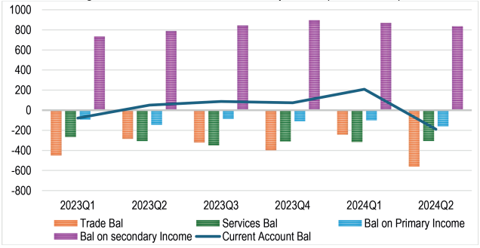

*Source: RBZ and ZimStat Estimates*

3.3.3 The current account surplus is anticipated to shrink to US$44.5 million by the end of 2024, down from the US$133.9 million surplus recorded in 2023. This reduction can be attributed to several factors, including lower commodity prices, especially for lithium and platinum group metals (PGMs), a slowdown in export growth, and an increased need for food imports due to climatic disruptions. These factors have combined to place downward pressure on the country's external balance.

## 3.4 Public Debt Developments

3.4.1 By the end of June 2024, the country's debt reached ZiG287.2 billion, with external debt at ZiG168.5 billion and domestic debt at ZiG118.7 billion as illustrated in table 2 below. This distribution shows that 58.7% of the debt is external, while 41.3% is domestic. When converted to US dollars, the total debt is approximately US$21 billion, consisting of US$12.3 billion in external debt and US$8.7 billion in domestic debt.

3.4.2 Government remains committed to the engagement and reengagement agenda through the implementation of the Structured Dialogue Platform Process (SDP). At the African Development Bank’s 2024 Annual Meetings held in Nairobi, Kenya, in May, H.E. J. A. Chissano, former President of Mozambique and High-Level Facilitator for the SDP, provided an update on the ongoing dialogue concerning Zimbabwe's public debt situation. He reported that five dialogue meetings have been conducted so far, involving the Zimbabwean government, the private sector, civil society, and development partners. H.E Chissano emphasized that these meetings have fostered mutual trust and confidence, resulting in robust engagement and leading to important concessions.

Table 2: Total Debt Stock as at 30 June 2024 (ZiG millions)

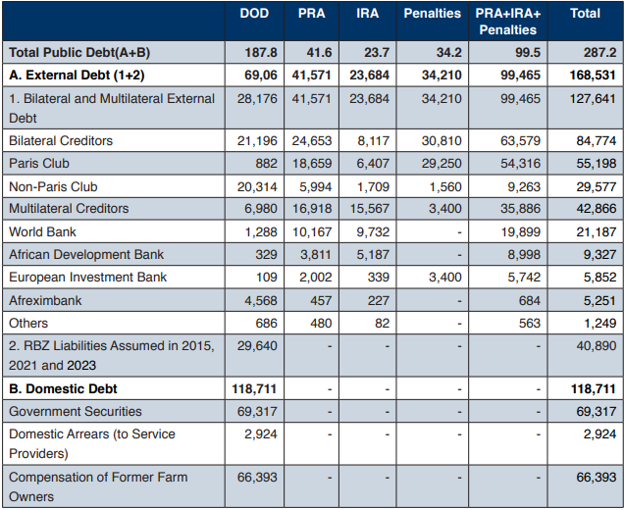

*Source: Public Debt Management Office and The Reserve Bank of Zimbabwe*

3.4.3 Marie-Laure Akin-Olugbade, the Bank’s Vice President for Regional Development, outlined the African Development Bank's initiatives to support Zimbabwe in clearing its arrears. Key actions include the establishment of anti-corruption courts, reforms for transparent justice and electoral processes, and efforts to promote peace, unity, and reconciliation. Additionally, the Zimbabwean government has allocated $55 million in its 2024 budget to compensate former commercial farm owners and fulfil obligations under the Bilateral Investment Protection and Promotion Agreement (BIPPA). The government has already announced a call for BIPPA farmers to submit their claims, with payments scheduled to begin in June 2024.

3.4.4 The significant debt burden facing Zimbabwe (58.7% external and 41.3% domestic) poses substantial challenges to the country’s economic stability. High debt levels constrain fiscal space, limiting the government's ability to invest in essential public services and infrastructure. The large share of external debt exposes Zimbabwe to foreign exchange risks and may lead to higher debt servicing costs, which can crowd out private investment and slow economic growth.

3.4.5 Moreover, the need for effective debt management and engagement with international creditors, as highlighted by the Structured Dialogue Platform Process and support from the African Development Bank, underscores the urgency of fiscal reforms. These reforms are crucial to restoring investor confidence, managing debt sustainability, and mitigating the adverse impacts of high debt on economic development and social welfare. Without substantial progress in these areas, Zimbabwe risks facing increased economic instability, reduced development prospects, and potential social unrest.

## 3.5 New Currency Introduction

3.5.1 On the beginning of the 2nd quarter, the Reserve Bank of Zimbabwe (RBZ) in its 20204 Monetary Policy Statement (MPS) introduced a structured currency called Zimbabwe Gold (ZiG) to replace the Zimbabwean dollar. The ZiG is pegged to a specific exchange rate or currency basket and backed by a bundle of foreign exchange assets (potentially including gold). According to the MPS, foreign currency balances will be accumulated through market purchases from the 25% surrender requirements as well as sale of some precious metals received as royalties.

3.5.2 As at 5 April 2024, the RBZ reserve asset holdings comprised of USD 100 million in cash and 2,522 kg of gold (worth US$185 million) totalling to US$285 million to back the entire local currency component of reserve money which current stood at ZW$2.6 trillion requiring full (100%) cover of gold and cash reserves amounting to US$90 million.

3.5.3 The introduction of the structured domestic currency, the ZiG, on April 5, 2024, marked a significant milestone in the phased de-dollarisation strategy. This initiative aims to achieve macroeconomic stability by re-establishing a mono-currency system, which is expected to stimulate domestic production and enhance export performance.

## 3.6 Exchange Rate System

3.6.1 The starting exchange rate on the introduction of the ZiG was USD/ZiG 13.5616 determined by the prevailing closing interbank exchange rate as at 5 April 2024 and the London PM Fix price of gold as at 4 April 2024.To ensure currency and exchange rate stability, the RBZ replaced the auction system by a refined interbank foreign exchange market under a willing-buyer-willing-seller (WBWS) trading arrangement where trading liquidity was to be provided using the 25% surrender proceeds from exports.

3.6.2 During the review period, the ZiG, has shown good stability. This achievement is especially noteworthy as it represents the first time since its introduction that the currency has maintained a consistent exchange rate. The successful efforts to curb parallel market activities have played a crucial role in this stability, significantly lowering the premiums associated with such market, as shown in Figure 5.

3.6.3 The stability of exchange rates and price levels can be primarily credited to the diligent oversight and monitoring efforts of the Financial Intelligence Unit (FIU). The FIU's active initiatives to address economic misconduct have been crucial in bolstering market confidence and sustaining a balanced economic environment. Their actions have not only discouraged speculative activities but have also promoted a more transparent and accountable financial system.

Figure 5: Exchange Rate Movements

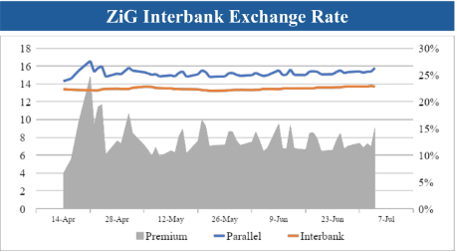

*Source: Reserve Bank of Zimbabwe*

## 3.7 Money Supply and Interest Rate Developments

3.7.1 The stock of reserve money stood at ZiG6.6 billion in May 2024, compared to ZiG6.5 billion in April 2024. The reserve money stock comprised of a foreign currency component, ZiG5.6 billion; and a local currency component, ZiG1 billion. The US dollar equivalence of the local currency component of the reserve money amounted to US$77.4 million as at end of May 2024, well below the international reserves backing the currency, which amounted to US$349 million.

3.7.2 On interest rate policy, the Reserve Bank recalibrated the Bank policy rate from 130% per annum to 20% per annum consistent with the new monetary policy framework. Minimum savings and time deposits interest rates on ZiG are set at 9% and 7.5% below the Bank deposit facility rate of 12.5%, respectively. Minimum interest rates on FCA deposits remain unchanged at 1% and 2.5% for savings and time deposits, respectively.

3.7.3 Under open market operations (OMO), the Reserve Bank indicated that they will be carried out to ensure that reserve money will always be fully backed by a corresponding composite basket of reserve assets comprising precious minerals (predominantly gold) and foreign currency balances.

3.7.4 In order to alleviate bank charges, the Reserve Bank indicated that banks will not charge monthly bank maintenance or service charges for individual bank accounts with a conservative daily balance of US$100 and below or its equivalent in ZiG for a period of up to 30 days.

## 3.8 Equity Market Developments

**Zimbabwe Stock Exchange**

3.8.1 During the second quarter of 2024, the Zimbabwe Stock Exchange experienced a bearish trend, with the all-share index plummeting by 70.63% and the top ten index dropping by 13.71%. Despite these declines, trading activity showed remarkable growth with the value traded surging by 296.02%. Furthermore, market capitalization saw a substantial increase of 39.72%.

3.8.2 The local market sentiment was mixed, but overall positive, resulting in a 39.72% rise in market capitalization by the end of the quarter. On a Year-to-Date (YtD) basis, market capitalization has soared by 125.18%, and on a Year-on-Year (YoY) basis, it has skyrocketed by 572.15%. Nevertheless, there was an 8.67% decline in the value traded on a YtD basis, as reflected in Table 2.

Table 3: Zimbabwe Stock Exchange Movements

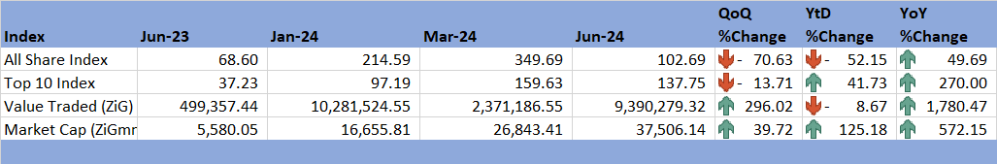

*Source: ZSE (2024)*

**Victoria Falls Stock Exchange**

3.8.3 During the quarter under review, the Victoria Falls Stock Exchange exhibited a bearish trend. Although the all-share index posted gains of 1.6% quarter-on-quarter (QoQ), 0.17% year-to-date (YtD), and 25.34% year-on-year (YoY), the value traded decreased significantly, losing 82.22% on a QoQ basis.

Table 4: Victoria Falls Stock Exchange Movements

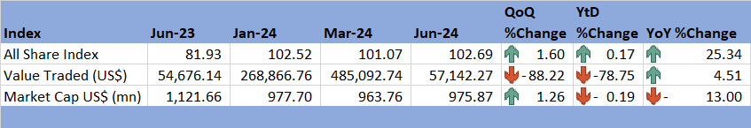

*Source: VFXE (2024)*

## Exchange Rate Developments

3.9.1 During the period under review, the ZiG depreciation against all major currencies, as illustrated in Table 4. On a quarter-on-quarter (QoQ) basis, the ZiG depreciated by approximately 55.15% against the US dollar. This depreciation is evidenced by the exchange rate movement from USD: ZiG 8.83 per USD at the end of March 2024 to USD: ZiG 13.7 per USD by the end of June 2024.

3.9.2 However, it is important to note that the substantial loss in value of the ZiG was primarily attributed to the currency's conversion from the previous Zimbabwean dollar (ZWL) to the new ZiG. This conversion process contributed significantly to the observed depreciation, reflecting both the immediate market adjustments and underlying economic conditions.

Table 5: ZiG Exchange Rate Movements

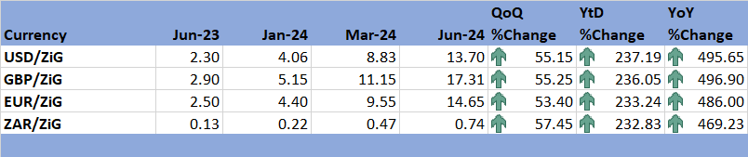

*Source: RBZ (2024)*

# 4.0 Social Factors

## **4.1 Education**

4.1.1 Zimbabwe boasts an adult literacy rate of 87.70%, with a notably high gross enrolment rate in primary education, underscoring the nation's strong emphasis on education. The 2024 National Budget allocated ZiG 15.4 billion to enhance access to quality and equitable education at both basic and tertiary levels. This allocation represents 4.05% of the total national budget and supports the transformation of the education system through Education 5.0, which aims to cultivate creative thinking, innovation, and an entrepreneurial mindset among students.

4.1.2 However, the ongoing El Niño phenomenon threatens approximately 1.8 million students across Zimbabwe's 72 education districts, with over 1.24 million students in the 30 hardest-hit drought districts facing the most severe impacts (Drought Flash Appeal, May 2024). The El Niño-induced drought is likely to exacerbate poverty levels, potentially increasing school dropouts as families struggle to pay school fees.

4.1.3 In response, the government has strengthened the Basic Education Assistance Module (BEAM) program, which assists vulnerable children aged 4 to 19 enrolled in Early Childhood Development (ECD), primary, secondary, and special needs schools. Recently, the BEAM Management Unit has been decentralized to provincial levels, and data collection and paysheet generation are now managed through a newly developed BEAM online system. This automation is expected to enhance information management and monitoring systems, thereby improving the program's effectiveness.

## **4.2 Health**

4.2.1 The El Niño-induced drought currently affecting Zimbabwe has heightened the risk of water insecurity for many residents. This situation has led to increased potential for poor hygiene practices and a higher likelihood of outbreaks of infectious and waterborne diseases. According to the drought flash report, as of April 8, 2024, there were 31,391 reported cases of cholera and 591 deaths (a 2.2% case fatality rate), with the outbreak initially beginning in February 2023. In response to this public health challenge, Zimbabwe was appointed Chair of the Southern Africa Taskforce on Cholera Prevention and Control in June, tasked with leading regional cholera control initiatives.

4.2.1 Global trends highlight that drug and harmful substance abuse result in approximately 3.3 million deaths annually, with 15.3 million people suffering from drug use disorders. In response to these issues, Zimbabwe launched the Zimbabwe Multi-Sectoral Drug and Substance Plan 2024-2030 during the second quarter. This comprehensive plan provides a detailed roadmap for the country's coordinated response to drug and substance abuse. The government has also stepped-up surveillance activities to curb drug supply and abuse, leading to the arrests and prosecutions of 8,521 individuals involved in drug dealing and use.

## **4.3** Poverty and Hunger

4.3.1 In 2024, an estimated 7.7 million Zimbabweans, including 6 million in rural areas and 1.7 million in urban areas, are projected to experience food insecurity and will require food assistance. To address this issue, the government has implemented a dual response strategy. This includes the importation of 300,000 metric tons of grain to be distributed to vulnerable populations. Additionally, the private sector is expected to import at least 464,000 metric tons of grain for sale through regular market channels.

4.3.2 To support the distribution efforts, the government has allocated ZiG 60.9 million for grain distribution from the Grain Marketing Board (GMB) stocks to 10 provinces during the first half of the year. As of June 15, 2024, this initiative has enabled the delivery of 32,241.2 metric tons of grain to households facing food insecurity, providing essential support to those in need across the country as indicated on Table 6.

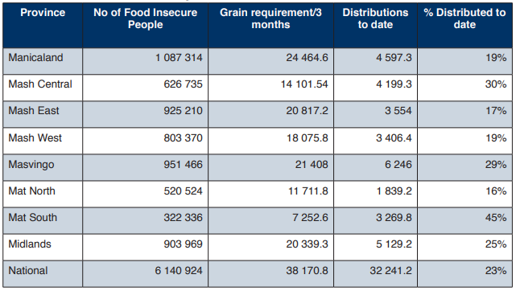Table 6: Grain Distributed by Provinces

*Source: Ministry of Public Service, Labour and Social Welfare*

# 5.0 Technological Factors

5.1 During the second quarter, a landmark agreement was formalized during the African Development Bank’s Annual Meetings in Nairobi, Kenya, between the African Development Bank and technology giant Intel. This partnership aims to transform the African digital ecosystem by equipping 3 million Africans and 30,000 government officials with advanced artificial intelligence (AI) skills. The initiative is part of a broader effort to develop a critical mass of Africans proficient in Fourth Industrial Revolution (4IR) technologies.

5.2 On the local front, significant efforts have been made to promote digital inclusion and infrastructure development. The Hon. Minister of Information Communication Technology, Postal, and Courier Services, has been spearheading the Digitalize Zimbabwe Campaign. This nationwide initiative aims to encourage citizens to engage with and benefit from the digital transformation. The campaign's focus areas include the expansion of broadband infrastructure, investment in last-mile connectivity, and the implementation of smart government systems and e-government programs.

5.3 From January to June 2024, the Zimbabwean government allocated US$1.5 million to upgrade existing fibre networks, establish new base stations, and enhance telecommunications services. These upgrades, carried out by service providers such as TelOne, Africom, and NetOne, are crucial as Zimbabwe prepares to host the 44th SADC Heads of State and Government Summit. The investments aim to ensure robust and reliable communication infrastructure for the event and beyond

# 6.0 Environmental Factors

6.1 The second quarter of 2024 was marked by significant global and national environmental initiatives, focusing on land restoration, desertification, and climate change resilience. These efforts are critical in addressing the ongoing environmental challenges and preparing for future impacts.

6.2 World Environment Day, celebrated on June 5th and led by the United Nations Environment Programme (UNEP), focused on the theme "Land Restoration, Desertification, and Drought Resilience." This theme highlights the urgent need to address land degradation, which currently affects up to 40% of the world's land area and impacts approximately 3.2 billion people. Projections indicate that by 2050, over three-quarters of the global population will experience the effects of drought. This year's observance serves as a precursor to the United Nations Convention to Combat Desertification (UNCCD) COP16, scheduled for December 2024 in the United Kingdom.

6.3 In Zimbabwe, significant progress was made in legislative efforts to combat the adverse effects of climate change. During the second quarter, extensive stakeholder engagements were conducted to finalize the Climate Change Bill. This proposed legislation aims to provide a comprehensive framework for integrating climate change mitigation and adaptation strategies into the country's development planning and budgetary processes. The Bill outlines specific guidelines for reducing greenhouse gas emissions, promoting low-carbon development pathways, and regulating carbon trading. It also proposes the establishment of a regulatory agency and a designated fund to support the implementation of robust climate change mitigation and adaptation measures, as outlined in Zimbabwe’s Climate Change Policy.

# 7.0 Legal Factors

7.1 The second quarter of 2024, one of the major legal developments was the announcement of the transition from the Zimbabwean dollar (ZWL) to a new currency, the ZiG. This shift was legally formalized through Statutory Instrument (SI) 60 of 2024, which laid out the regulations and guidelines for the implementation of the new currency.

7.2 Additionally, there were significant legal discussions and public engagement concerning the death penalty. Public hearings were conducted, revealing that approximately 85% of the public favoured the abolition of the death penalty. This overwhelming support for abolition reflects a shifting public sentiment towards more progressive human rights practices within the country's legal framework.

7.3 During the same period, the President of the Republic of Zimbabwe, acting on the recommendations of the Judicial Service Commission, appointed ten new judges to the High Court and one judge to the Administrative Court. These appointments are crucial for enhancing the judiciary's capacity and ensuring the efficient administration of justice in Zimbabwe. The new appointments also reflect an ongoing effort to strengthen the judiciary by bringing in fresh expertise and perspectives, which is essential for maintaining the integrity and independence of the judicial system.

# 8.0 Recommendations

8.1 The following recommendations are being proposed:

8.1.1 With global instability affecting energy and agricultural markets, Zimbabwe should continue diversifying its economy beyond reliance on traditional sectors like mining and agriculture. Expanding into manufacturing, tourism and technology can provide more stability and growth opportunities.

* + 1. The current infrastructure upgrades, such as the New Parliament Building and state-of-the-art villas, can be leveraged post SADC Summit for tourism, international conferences, and as diplomatic facilities. Promoting Zimbabwe as a prime location for international events can boost tourism and foreign investment.

8.1.3 The RBZ should ensure the ZiG is backed by adequate reserves, including foreign currency and precious metals, to maintain confidence in the currency and prevent speculative attacks. Transparent and consistent communication from the RBZ can help anchor inflation expectations. Conduct public education campaigns to build confidence in the ZiG, ensuring that the public and businesses understand the benefits and security of the new currency system.

8.1.4 The MoFEDIP should implement comprehensive debt management strategies that prioritize debt sustainability. There is need to engage in transparent reporting and accountability in the management of public funds. Additionally, there is need for continued dialogue with international creditors and financial institutions to restructure and resolve debt issues. Focus should also be on building strong relationships with multilateral organizations and bilateral partners.

8.1.5 Enhancement of regulatory framework for the Zimbabwe Stock Exchange (ZSE) and Victoria Falls Stock Exchange (VFEX) should be enhanced to increase transparency and investor protection. In the same manner there should be encouragement of local and foreign investors to participate in the equity markets by offering incentives such as tax breaks and ensuring a stable macroeconomic environment.

8.1.6 To mitigate the impact of the El Niño-induced drought on education, Government should establish emergency funds and food assistance programs to keep children in school. The Basic Education Assistance Module (BEAM) should be expanded to cover more students and provide additional resources for school infrastructure and supplies in affected areas. Partnering with private sector and international organizations to provide resources and training to educators should also be explored.

8.1.7 In order to Combat Drug and Substance Abuse, Government through the Ministry of Health and Child Care should implement the Zimbabwe Multi-Sectoral Drug and Substance Plan 2024-2030 effectively by ensuring adequate funding, training for healthcare professionals, and public awareness campaigns. Strengthening of law enforcement and judicial systems to tackle drug trafficking and distribution should be prioritised.

8.1.8 Government to expedite the passage and implementation of the Climate Change Bill, ensuring it includes specific measures for emission reductions and climate adaptation strategies. A Climate Change Fund is necessary to support these initiatives.

# 9.0 References

IMF. (2024). *World Economic Outlook Update, January 2024.* International Monetary Fund.

MOFEDIP. (2023). *The 2024 National Budget Statement.* Ministry of Finance, Economic Development and Investment Promotion.

MOFEDIP. (2024). 2024 *Mid-Term Budget and Economic Review*. Ministry of Finance, Economic Development and Investment Promotion

RBZ. (2024). *2024 Monetary Policy Statement.* Reserve Bank of Zimbabwe.

RBZ. (2024). *Exchange Rates*. Retrieved from Reserve Bank of Zimbabwe: <https://www.rbz.co.zw/index.php/research/markets/exchange-rates>

Trading Economics. (2024). *Commodities*. Retrieved from Trading Economics: https://tradingeconomics.com/commodities

VFEX. (2024). *VFEX Main Dashboard* . Retrieved from Victoria Falls Stock Exchange: https://www.vfex.exchange/

ZimStat. (2023). *2023 Third Quarter International Migration Statistics.* Zimbabwe National Statistics Agency.

ZimStat. (2024). *Inflation Rates*. Retrieved from Zimbabwe National Statistical Agency: https://www.zimstat.co.zw/

ZSE. (2024). *ZSE Main Dashboard*. Retrieved from Zimbabwe Stock Exchange: https://www.zse.co.zw/

# Annexes

## Annexture A: PESTEL-SWOT Analysis Matrix for the Quarter Ending 30 JUNE 2024

|  | **STRENGTHS** | **WEAKNESSES** | **OPPORTUNITIES** | **THREATS** |
| --- | --- | --- | --- | --- |
| **POLITICAL** | -Strong international engagement with international organisations and foreign Governments.  - Peaceful environment.  -Ongoing ease of doing business reforms.  -The country has well established institutions. | -dependence on external aid and debt causes vulnerability.  -lack of policy consistency.  - Corruption  - Rent seeking behavior. | -regional leadership and integration.  -Developmental oriented political manifestos.  -Reengagement with the international community  -public sector modernisation | -High country risk.  -Corruption  -Disputed elections- political uncertainty.  -Wait and see attitude of investors. |
| **ECONOMIC** | -Diverse economic base including mining, agriculture and manufacturing.  - The introduction of ZiG and efforts towards macro-economic stability.  -Low interest rates.  -Increasing Government Revenue.  -High financial audit standards. | -High public debt limiting fiscal space.  -Infrastructure deficiencies particularly in energy, water, and transportation.  -Dependence on agricultural sector.  -Rigid labour market regulations.  -Over-dependence on commodity exports.  -Porous borders.  -High tax evasion | -High GDP growth (3.5% in 2023).  -Investment in digital and technological infrastructure.  - Unfulfilled demand for energy.  -High Demand for infrastructure funding (water, transport, energy and housing).  -agricultural diversification innovation. | -Foreign currency shortages.  -Low levels of formal employment.  - Tight global financial conditions.  -High sovereign debt.  -Currency instability  -High Government deficit  - Strengthening US$  - Money laundering. |
| **SOCIAL** | - A high adult literacy rate of 87.70%  -comprehensive social assistance programmes  -High engaged population, peace and loving  - Proactive public health measures for example the Zimbabwe Multi-Sectoral Substance Plan.  - low levels of violence and crime. | - vulnerability to natural disasters e.g the ongoing Elnino.  - High Poverty levels and food insecurity levels (estimated 7.7 million people needing food assistance in 2024).  -Insufficient healthcare infrastructure. | -Population growth.  -Youthful population – demographic dividend.  -Increasing migrants – remittances.  -technological integration in social services.  -educational reforms and expansion.  -health sector improvement. | - impact of climate change on social stability  -drug and substance abuse.  -Low levels of formal employment  -Increase in organized crime and human trafficking. |
| **TECHNOLOGICAL** | -Commitment to digital inclusion.  -Significant investments in technology infrastructure.  -High ICT coverage in urban areas.  -High ICT usage  -High internet penetration levels – 73.3% | - Lack of resources to adopt new technologies and roll out appropriate products.  -Inadequate ICT coverage in rural areas.  -Slow pace in technological infrastructure development.  -dependency on external technology providers. | -Development of ICT backbone in rural areas.  -expansion of e-government services.  -leverage technology for social and economic development. | - cybersecurity risks.  -risk of widening the digital divide if infrastructure and skills development are not evenly distributed. |
| **LEGAL** | -Judicial Independence  - Ease of doing business reforms.  - Supportive legal environment. | - Slow progress in passing Bills that are meant to promote ease of doing business.  -lingering issues related to public trust in the legal system particularly legal reforms and appointments. | -Special Economic Zones Act/ Policy.  -Ease of Settling, Commercial and other Disputes Bill.  -Amendment of the Indigenization and Economic Empowerment Policy  -Abolition of death penalty aligns with progressive human rights standards. | -Slow progress in resolving commercial court cases.  -judicial independence  -potential for legal disputes with the transition to new currency. |
| **ENVIRONMENTAL** | -Active environmental engagement.  -Legislative efforts (Climate Change Bill) | - High regulatory fees.  -vulnerability to climate change | -Increasing global and national interest in climate change.  -public awareness and education. | - Environmental degradation  -implementation and enforcement of environmental regulations. |

**NECF Secretariat 2024**